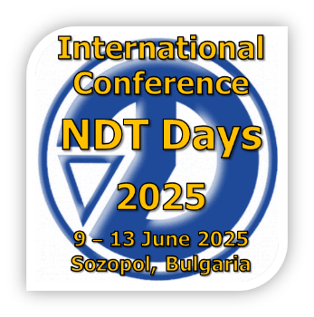 | REGISTRATION FORM
First name and family name
Educational degree  (please, delete unnecessary) | Prof., Assoc.Prof., Assist.Prof., PhD-Student, Student, NDT-degree
Member of BG-S-NDT (yes/no)
Affiliation:
organization
VAT-number
address
phone:
e-mail:
type of participation  (please, delete unnecessary) | - oral presentation  - poster  - firm presentation  - firm exhibition  - firm advertisement  - without paper
I will participate  with presentation or poster  in (please, delete unnecessary) | - XXXX Conference “Defectoscopia 2025”, Chairmen: Assoc. Prof. Y. Mirchev, Eng. R. Dimitrov  - XXXVI Youth Training Session “Non-destructive testing of structure, physical and mechanical properties of materials”, Chairman: Assoc. Prof. Y. Mirchev  - Day of the Defectoscopist, Chairmen: Assoc. Prof. Y. Mirchev, Eng. R. Dimitrov  - Seminar “Non-Destructive Testing of material, products and installations” Chairmen: Assoc. Prof. Y. Mirchev, Assoc. Prof. Y. Lysenko  - Seminar “Innovative methods and techniques for testing”, Chairmen: Assoc. Prof. Iv. Georgiev, Assoc. Prof. Y. Mirchev  - Seminar “Testing of materials and technological process for their processing”, Chairmen: Assoc. Prof. T. Mechkarova, Assoc. Prof. Y. Mirchev  - Round Table “Powder metallurgy”, Chairman: Prof. M. Sulowski, Prof. Vl. Petkov  - Round Table “Standardization in NDT”, Chairmen: Assoc. Prof. Y. Mirchev, G. Ilieva  - Round Table “Cooperation of accredited laboratories and inspection bodies with EA Bulgarian Accreditation Services” Chairmen: Eng. I. Borislavova, Eng. R. Dimitrov  - Poster session, Coordinators: Assoc. Prof. Kr. Ivanova, Assoc. Prof. Y. Mirchev  - Exhibition of firms and business presentations
Information about the article:
article name in English
author(s) name(s)
abstract
If article is not in English:
article name
in Bulgarian/Russian
author(s) name(s)
in Bulgarian/Russian

Please, write here all authors in order of appearance in the paper.

